POST 1: What’s new this month

CAPTION:

This March, we’re putting out something brand new at the library. 📚

This month we've got a research scavenger hunt built around four genuinely surprising mysteries, an AI vs. real photo challenge that's trickier than it looks, and a printable for anyone who has strong opinions about cell phones in school and has never been asked to actually defend one.

Everything is printed and ready to grab. Come find us.

#LibraryLife #Infobase #SchoolLibrary #LibraryLearning

GRAPHIC:
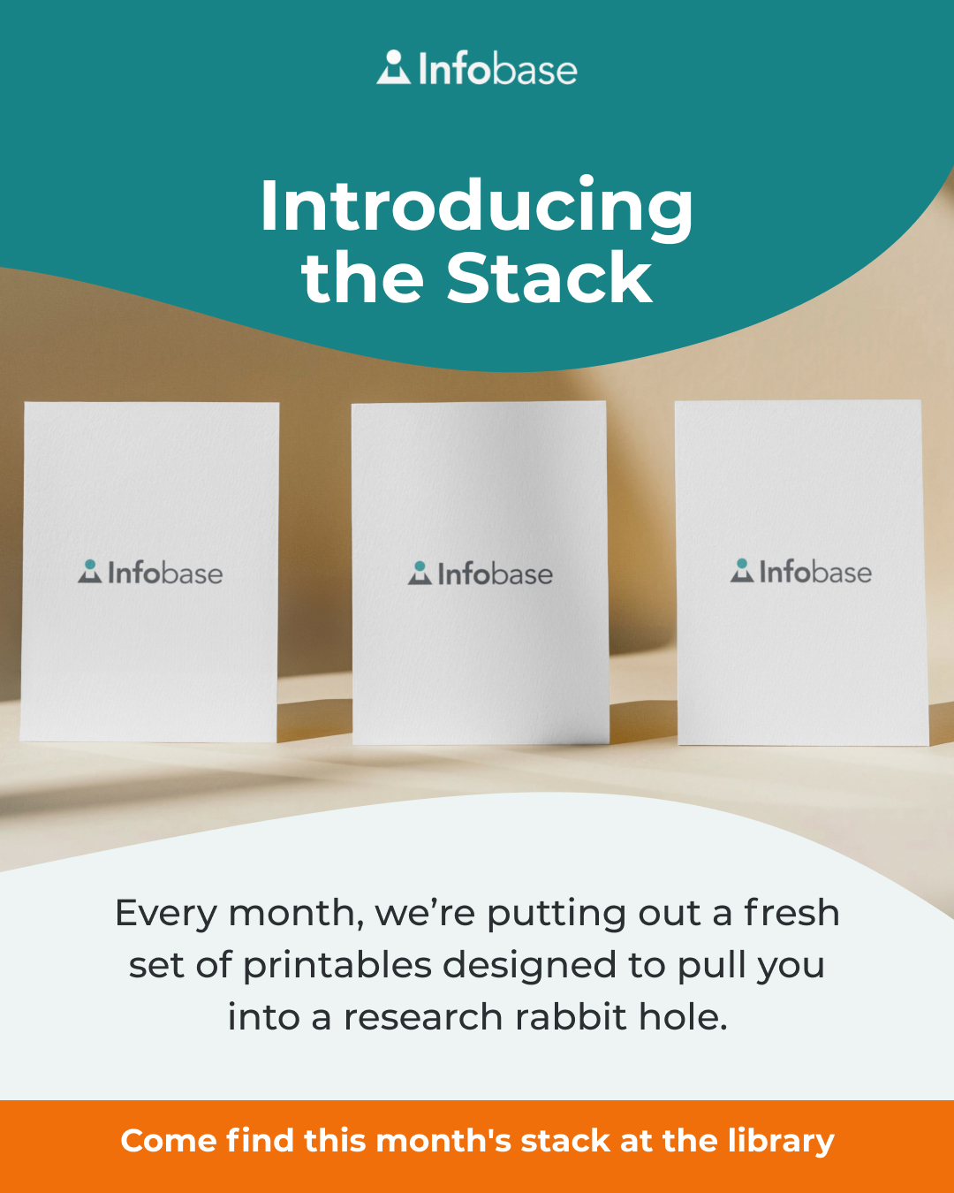

POST 2: Why do identical twins have different fingerprints?
Printable Post

CAPTION:

If identical twins share 100% of the same DNA, why do they have completely different fingerprints? 🧬

We left four clues at the reference desk. It sounds like it should be simple, but it's a trickier case to crack than you might think.

🔍 Clue 1: Is a clone really an exact copy?
🔍 Clue 2: What did NASA learn from twins in space?
🔍 Clue 3: What do fake fingerprints reveal about the sense of touch?
🔍 Clue 4: How do two identical people get a little more different, day by day?

It's one of four mysteries in this month's research scavenger hunt. Stop by and try to solve it. 🕵️

#LibraryLife #Infobase #SchoolLibrary #LibraryLearning

CAROUSEL POST SLIDES:

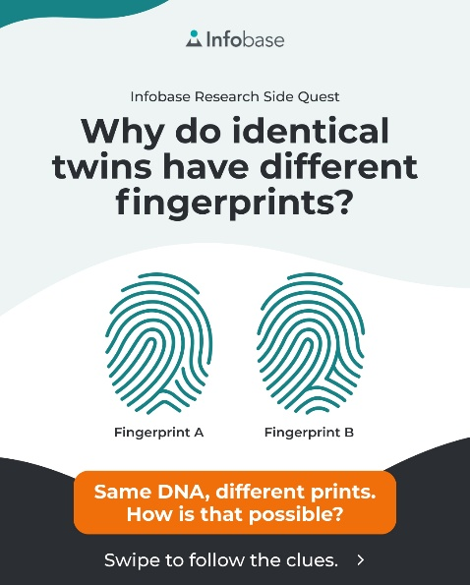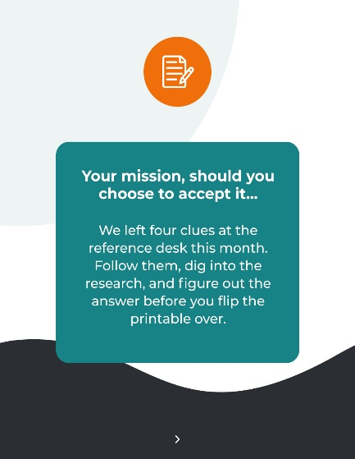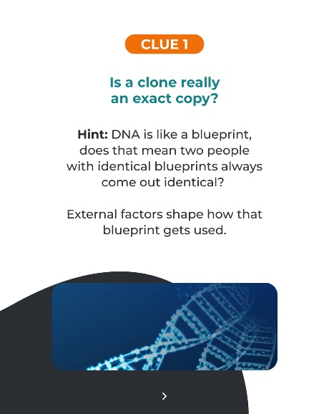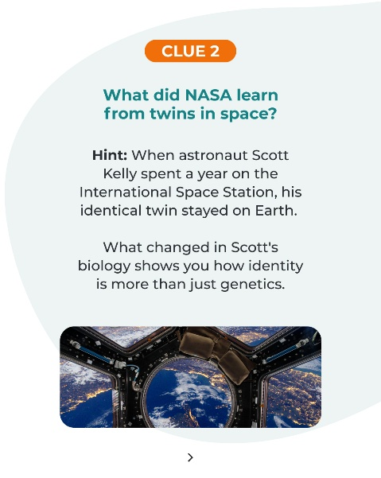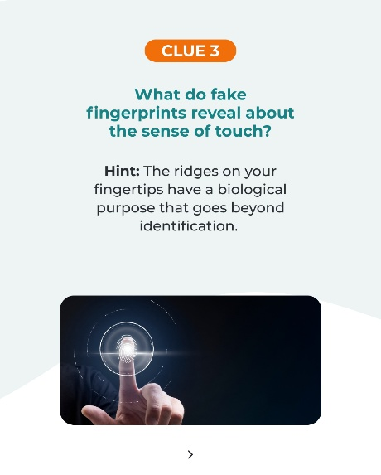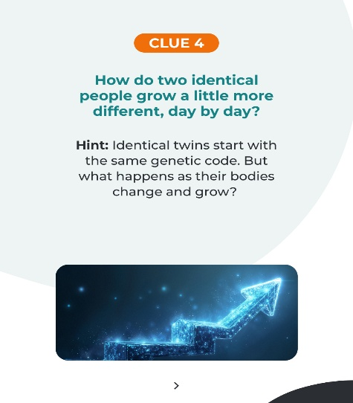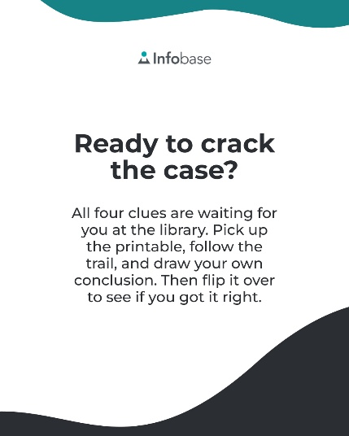

POST 3: Does the Internet have a physical location?
Printable Post

CAPTION:

Somewhere, there's a wire carrying your last message.

Millions of miles of them, actually.

Want to learn how they connect to your clicks? 🌊

This is one of the questions in our research scavenger hunt this month. Stop by and follow the trail… and you’ll never think about WiFi the same way again.

#LibraryLife #Infobase #SchoolLibrary #LibraryLearning

GRAPHIC:
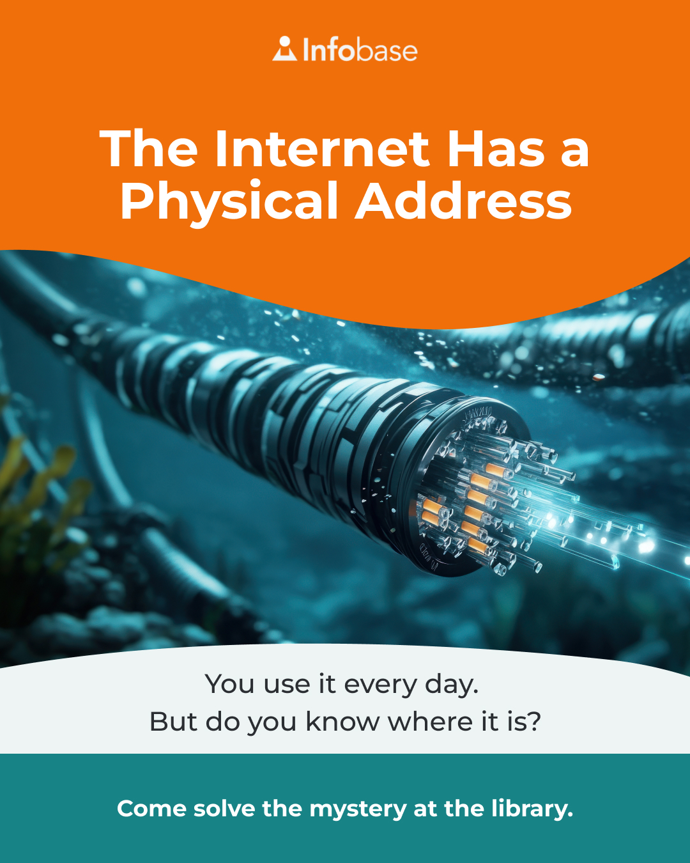

POST 4 — Why does the ocean have tides but lakes don’t?
Printable Post

CAPTION:

Do lakes have tides like the ocean?

We put this question out this month and asked students to figure out the full explanation before they flipped it over. It involves the moon, the sun, and why size actually matters in physics.

It's at the library. Come give it a try!

#LibraryLife #Infobase #SchoolLibrary #LibraryLearning

GRAPHIC:
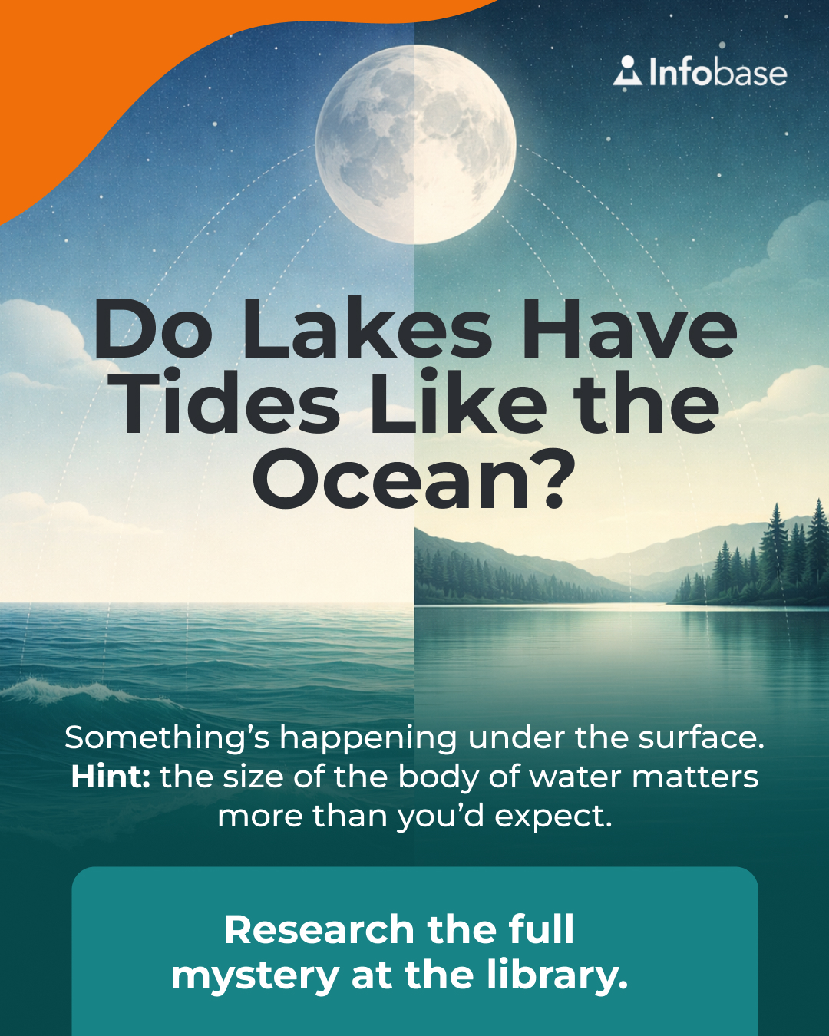

POST 5 — How did people wake up before alarm clocks?
Printable Post

CAPTION:

Before alarm clocks existed, people still had to wake up on time. So how did they do it? 🪟

This is the last of our four research mysteries this month, still out at the library if you haven't made it in yet.

Come find out what else people once used to wake up in the morning… before someone invented a clock that yelled at them. ⏰

#LibraryLife #Infobase #SchoolLibrary #LibraryLearning

GRAPHIC:
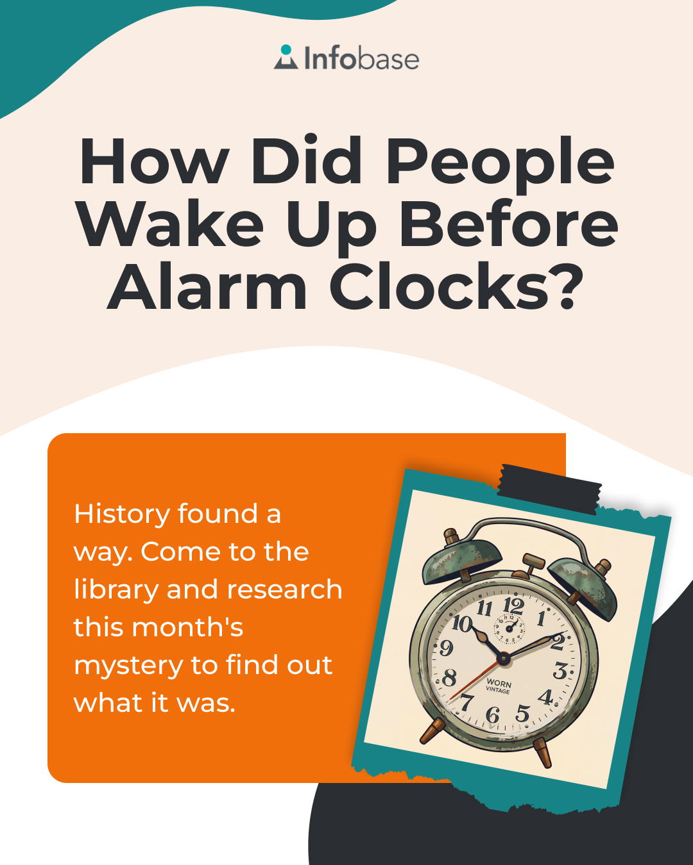

POST 6 — Spot the Twin: A Guide to AI vs. Real Photography
Printable Post

CAPTION:

I spy with my little human eye... one photo that's real, and one that was made by AI. Can you tell which is which? 👁️

The real photo is from 1899, and it's one of the most dramatic real photographs ever taken. This is exactly what makes it so challenging to tell these images apart.

We put both versions out this month and asked people to study them before they made their call. Some got it right. Some did not.

Can you spot the fake?

#LibraryLife #Infobase #SchoolLibrary #LibraryLearning

GRAPHIC:
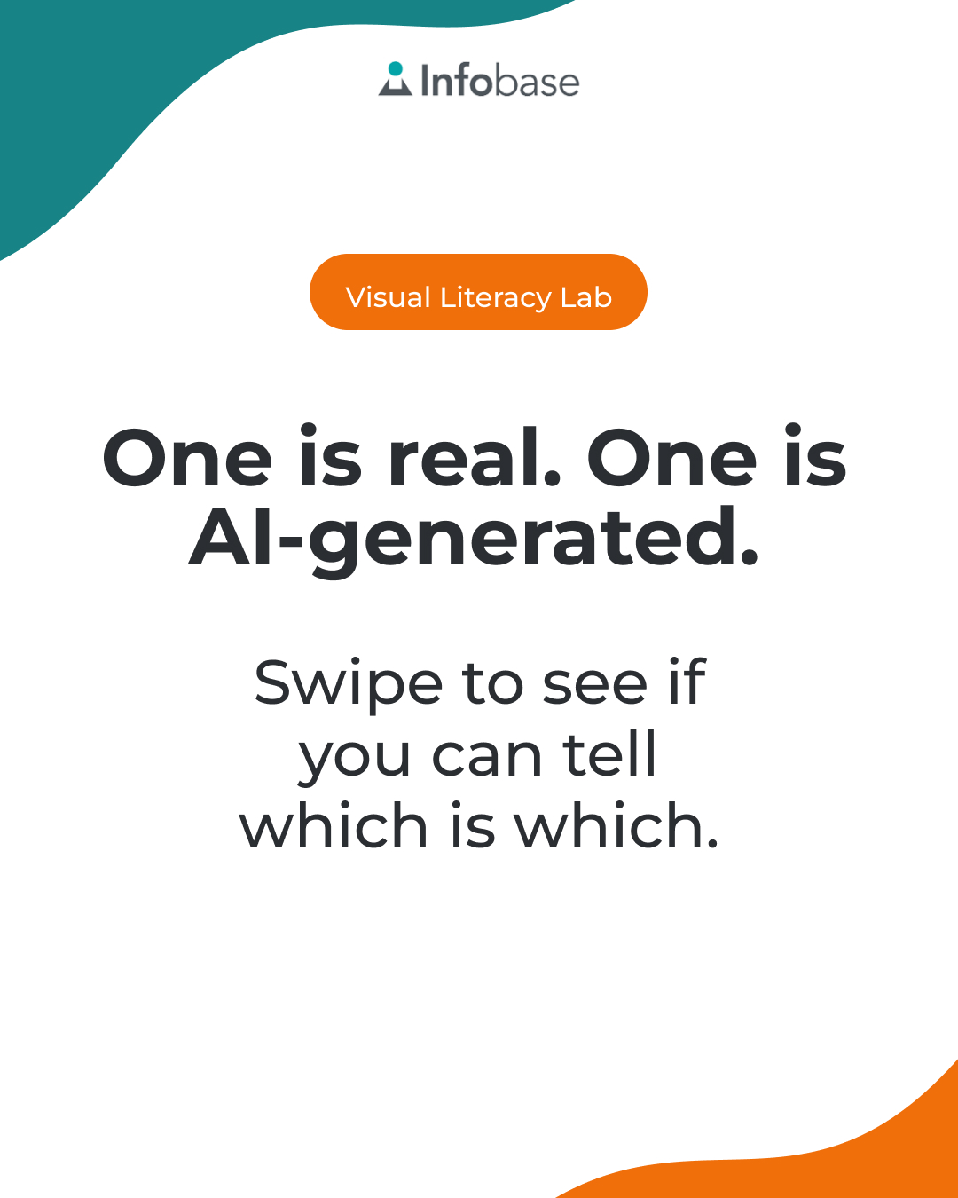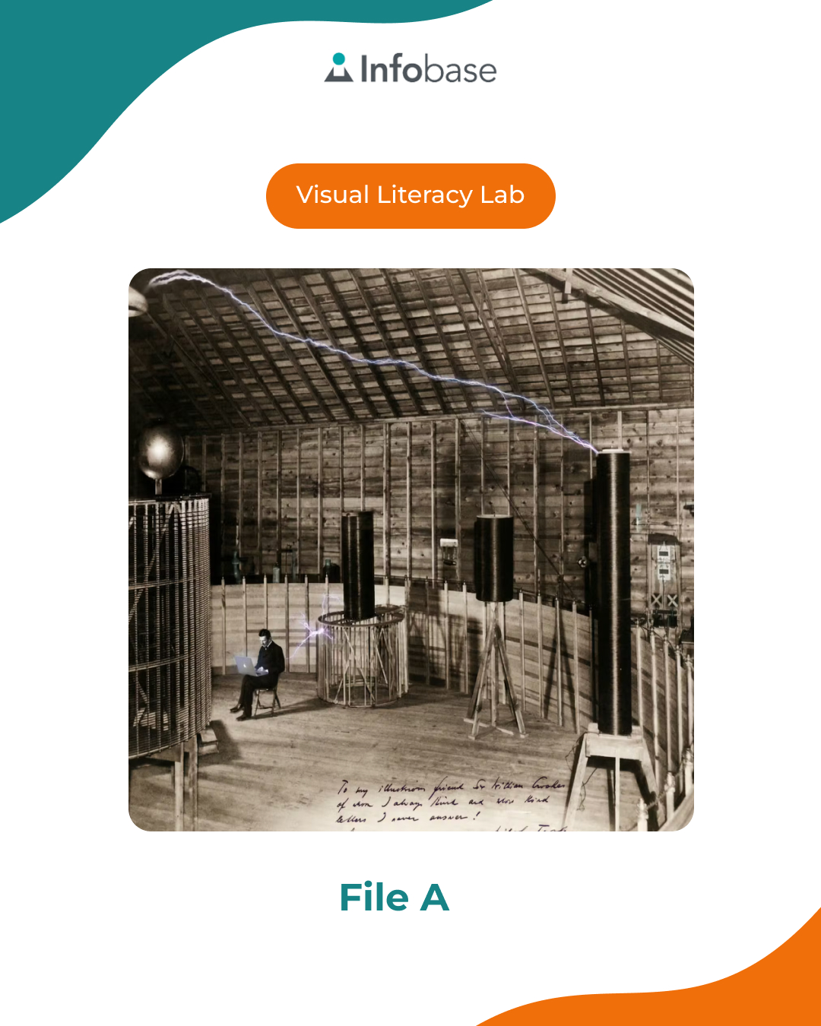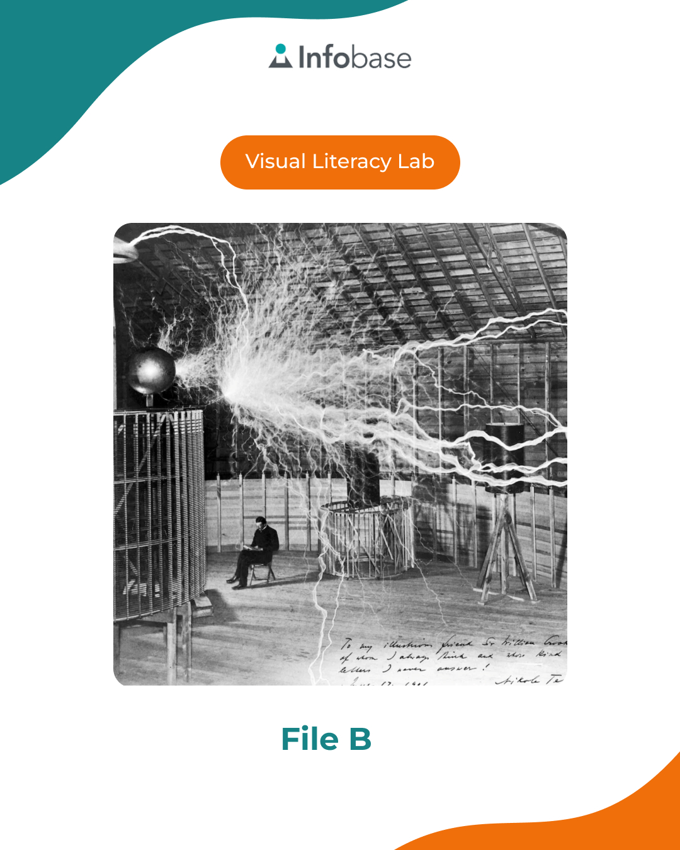

POST 7 — Both Sides of the Feed: Should Schools Ban Cell Phones?

Printable Post

Should schools ban cell phones? You probably already have an opinion. 📱

But have you considered both sides?

We put out a printable this month that breaks down the full debate. Not to tell you what to think, but to ask you to do something harder than having an opinion: do a little research on the points made by both sides.

All the materials you need are at the library. Come make your case!

#LibraryLife #Infobase #SchoolLibrary #LibraryLearning

GRAPHIC:
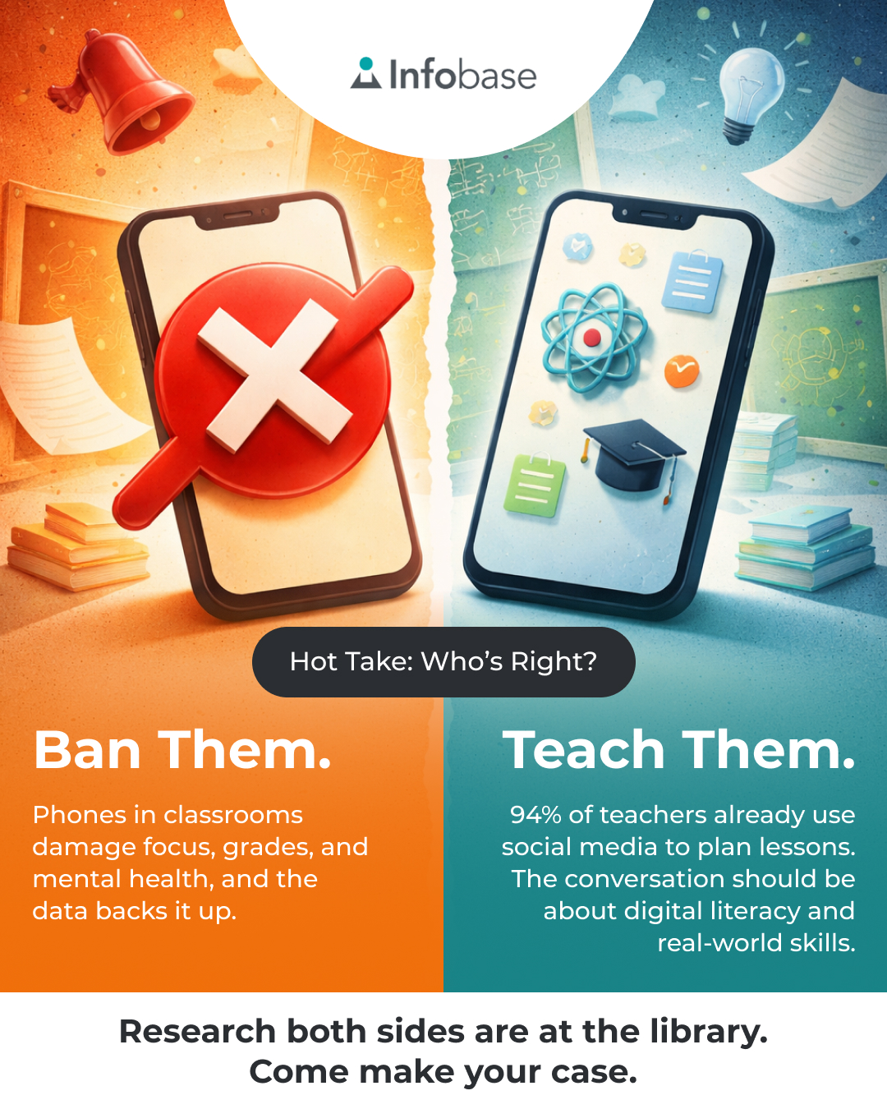

POST 8
Bonus Post: National Library Week (to be posted April 19-25)

It's National Library Week, and this year's theme is “Find Your Joy!” ☀️

Whether your joy is a gripping story you can't put down, a documentary rabbit hole at 11pm, a quiet table and a stack of comic books, or a scavenger hunt printable you grabbed on your way out, this is the place for it.

We're celebrating all week, come find what sparks joy at the library! ✨

#NationalLibraryWeek #FindYourJoy #LibraryLearning #Infobase #LibraryLife

GRAPHIC:
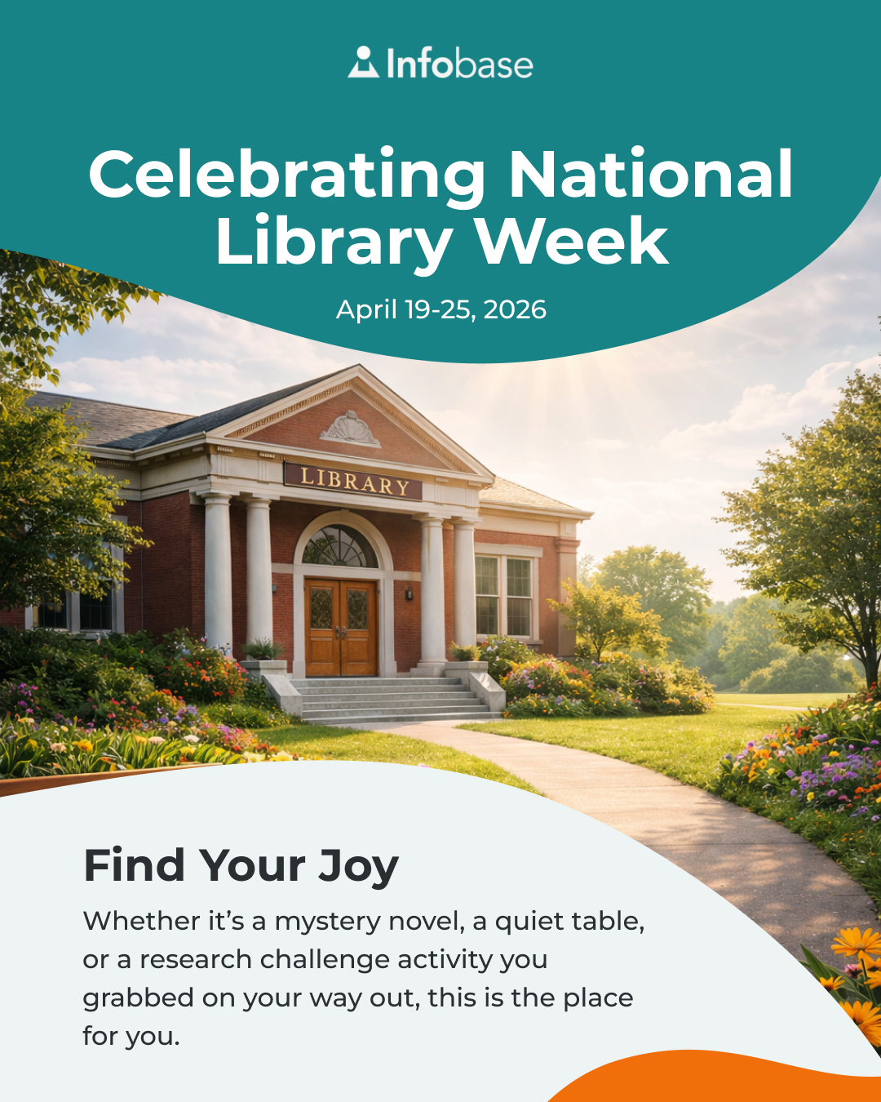

POST 9
Bonus Post: Earth Day (to be posted April 22)

Earth Day reminder: borrowing a book is one of the most #sustainable things you can do. 🌍

One copy can reach hundreds of readers without any packaging, shipping, or algorithm deciding what you see next. Libraries have been championing slow, quiet, planet-friendly activities for a very long time.

All you really need is a library card.

Come check something out today! 📚

#EarthDay #EarthDay2026 #LibraryLearning #Infobase #LibraryLife

GRAPHIC:
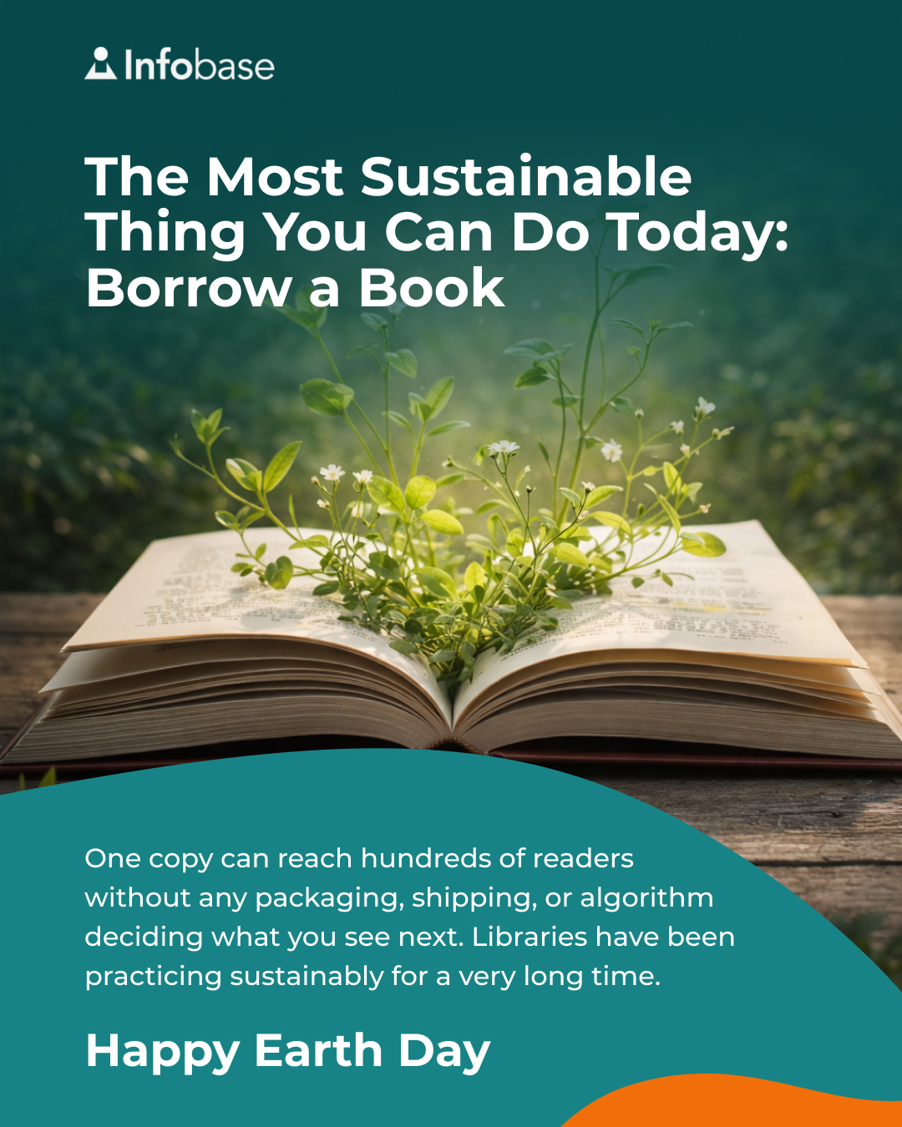

POST 10
Bonus Post: National Humor Month / April Fools’ Day

April is National Humor Month! At the library, we are taking that very seriously 😂

Here are five recently published middle-grade books that made us actually laugh out loud:

📖 “Wayside School Beneath the Cloud of Doom” by Louis Sachar, the fourth installment in the beloved absurd series, featuring a condition called "oppositosis" and to-do lists involving toenail clippings. Classic Wayside.

📖 “Busted” by Dan Gemeinhart, a ridiculous, genuinely fun adventure about a boy raised in a retirement community who teams up with a retired mobster. Yes, really.

📖 “Dino Poet” by Tom Angleberger, perfect for fans of Dav Pilkey, and a great companion to the Cat Kid Comic series. Dinosaurs. Poetry. Need we say more?

📖 “They Call Me No Sam!” by Drew Daywalt and Mike Lowery, from the creator of “The Day the Crayons Quit,” a heavily illustrated novel about a very noble pug who causes absolute chaos while trying to protect his family.

📖 “Mrs. Penny Pickles Puzzle Quest” by Chris Grabenstein, high-energy, puzzle-packed, and basically “The Amazing Race” for middle schoolers.

Stop by the library to find your next favorite funny book 📚

#NationalHumorMonth #AprilFools #BookRecs #LibraryLearning #Infobase #LibraryLife

GRAPHIC:
